Club Penguin Mission 2 Cheats
1. Go to the Sport’s Shop and speak to G.
2. Go to the Mountain and click on the Signs, using the code on the bottom-right of the screen to decode the green sign.
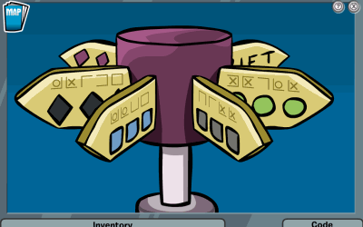
3. Go back to the Sport’s Shop and give G the secret word that you decoded. G will give you access to a Sled. It is usually mogul. Take the sled.
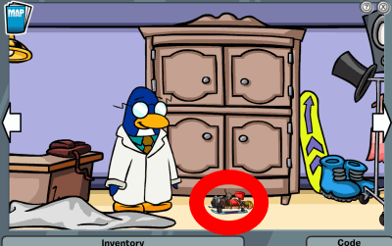
4. Go back to the mountain and use the sled on the Test Run, you must crash (you cannot win).
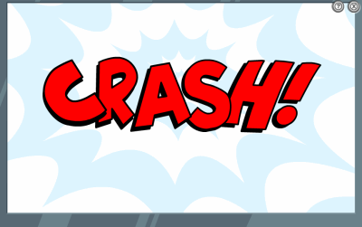
5. You’ll awake in the wilderness. Pick up the rope and Survival guide, and head to the bush.
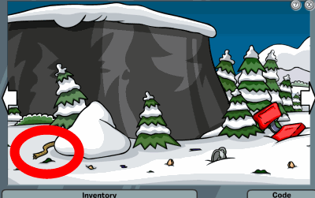
6. At the bush, collect 3 O-berries and then head to the stump. All the Puffles will run away except the black one. Feed it an O-berry and it will begin following you.
7. Go back to the O-berry bush and to the right you’ll see something in a tree. Shake in three times and a pot will fall out. Pick it up and put it into your inventory.
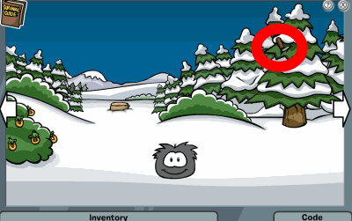
8. Go back to a Tree Stump. Then put your mouse over the arrow on the Left. Now go to the Fallen Tree and Bush. Take the Ski out of the Bush. Then take the Rope and put it on the Ski. They will form a fishing rod. Then take an “O” Berry put it on the fishing rod. The “O” Berry will become the Bait. Go back to the O-berry bush and put your mouse over the arrow on the Left. Then go to the river.
9. At the River, collect the log and then go far left and fill your pot with water. Then, attach the rope and an O-berry to your fishing rod and catch a fish. Pick the fish up.
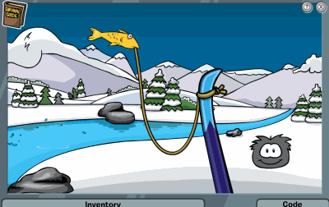
.
10. Go to the cave and push the bushes aside and enter the cave.
11. Go right and click on a rock to push them together. Put the log on it and the survival guide where the rocks are.
12. Then, feed your black puffle another O-berry and it will light the fire. Place the water on the fire and drink it.
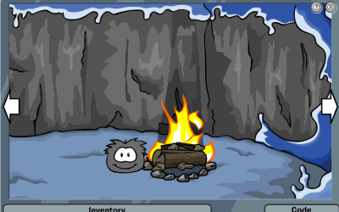
13. Place the fish on the fire and then eat it.
14. You will fall asleep, when you awaken go outside of the Cave and you will be rescued. Redeem your medal and letter and you’re done!
